Terminal: A text input and output environment.
- It is faster.
- Access to hidden data can be done using terminal.
- Though Command Line, Terminal, Console, Shell are slightly different they can be used interchangeably.
- Absolute Path works always, but when we use Relative Path, it is mandatory to know in which directory we are currently in.
- cd /: Root Directory
- cd ~: Home Directory
- Once a file or directory is deleted using terminal, we can’t get them back.

S. No. | Commands | Work
1. | ls (List files) | Show all the files and directories.
2. | pwd (Print working directory) | Where am I?
3. | clear | Clear the screen.
4. | cd (Change directory) | Can be used to hop between different directories.
5. | cd .. | Used to get one level down.
6. | mkdir | Make directory.
7. | man (Manual) | Give information about another command.
8. | touch | Used to create new files.
9. | rm | Used to remove files.
10. | rmdir  rm -rf | Used to remove empty folders.  Remove any folders.

Git: Free and open-source version control system (tool that helps to track changes in code).

GitHub: Website where we host repositories online.

- Readme: It is a type of detailed description of our repository, which gives a better understanding of our code.
- Commit: It gives the number of changes which took place in our repository.

Note: In Git, new files start as untracked. Once we run git add, they become tracked. If we modify a tracked file, Git marks it as modified. After staging the modified file with git add, we commit the changes, and once we push them, the updates become visible in the GitHub repository.
Some important Git commands:
- git clone <link>: Cloning a repository on our local machine.
- git status: Display the state of the code.
- git add <fileName>: Adds new or changed files in your working directory to the Git staging area.
- git commit -m “msg”: It is the record of the change.
- git push origin main: Upload local repo content to the remote repo.
- git init: It is used to create a new Git repo.

How to push a local repository into GitHub:
To push a local project to GitHub using Git, first navigate to the project folder and run git init to initialize it as a repository. Then create a new repository on GitHub and copy its HTTPS link. Add this link as your remote using git remote add origin <link>. You can verify the remote with git remote -v and rename the current branch as main using git branch -M main. Finally, push your code using git push origin main.
Note: When we push a local repository to GitHub, only the files that have been added and committed are uploaded. Simply initializing a repo and pushing it does not automatically upload every file. To include the files inside the folder, we must explicitly run git add, then git commit, and finally git push.

Git Branches: Branches in Git make collaboration easier. When multiple developers work on the same project but handle different features or tasks, each person can work on their own branch without affecting the main code. Once their work is complete, the branches can be merged into the main project based on the requirements.
Some important Git Branch commands:
- git branch: To check current branch.
- git branch -M main: To rename the current branch.
- git checkout <branchName>: To navigate b/w branches.
- git checkout -b <newBranchName>: To create new branch.
- git branch -d <branchName>: To delete a branch.

The proper workflow creating and merging two branches is: create a new branch with git checkout -b feature, make your changes, and push it to GitHub using git push origin feature. On GitHub you then open a Pull Request and merge the feature branch into the main branch. After the merge happens online, your local repository won’t automatically have those changes, so you switch to your local main branch using git checkout main and update it with git pull origin main. This downloads the merged changes into your local machine. Optionally, you can delete the feature branch both locally and on GitHub once everything is merged.
Merge Conflict is an event that takes place when Git is unable to automatically resolve differences in code between two commits.

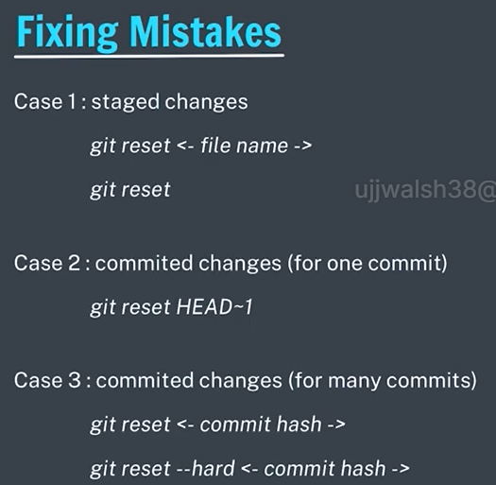
Using these commands, we can fix our mistakes or go back to earlier situation, maybe we want to go back to the situation which was there 2 commits back.

Fork: A fork is a separate copy of the original (upstream) repository that keeps the same code and visibility settings. You can propose changes back to the original project by creating a pull request from your fork to the upstream repository.

